**Expedite Portal Support Guide:**

This portal was created for the main purpose of helping provide the support user a platform where they can expedite incidents and view history of all the open expedited incidents by them and the queue they are assigned to. The portal consists of three main pages, the “Home page”, “My Expedited Incidents” and “Expedited Incidents”.

**Expedite Portal – Home Page**

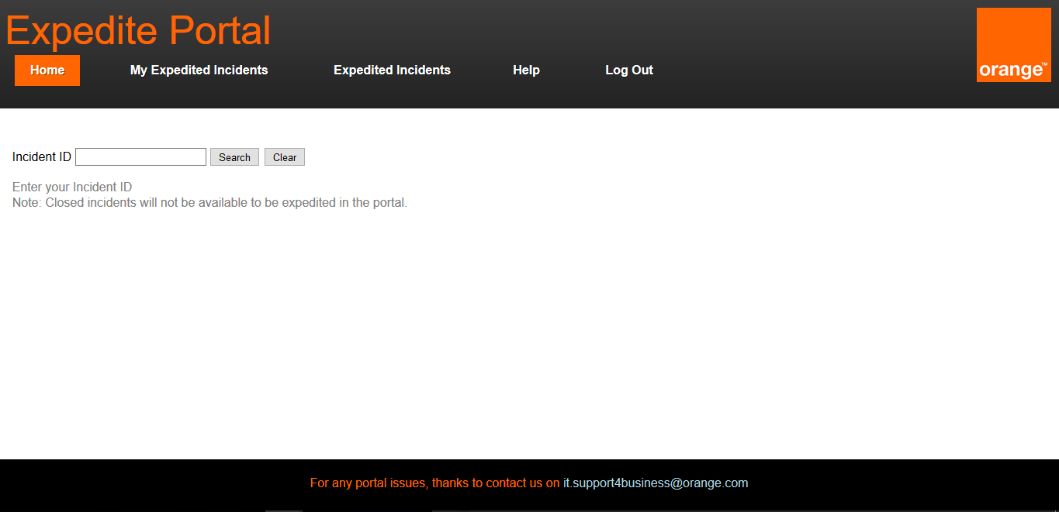

In this page the support user can search for any Incident number by typing the Incident ID and pressing on “Search” button. After searching for the incident the details of the incident will be shown and whether it is available for expediting or it has already been expedited. Incidents that are closed will not be available on the portal for expediting. Moreover any Incident which has not yet been reflected in the portal will take around 30 minutes to be available for expediting on the portal. If the Incident is not expedited the support user can press on the “Expedite” button which will show the user the following view.

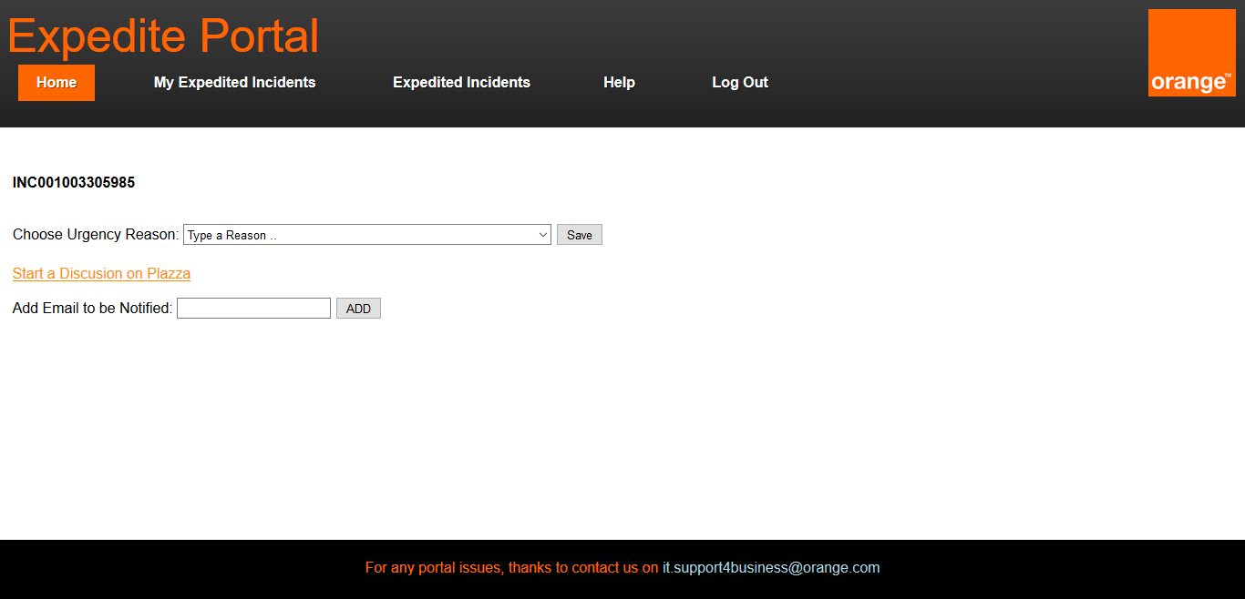

Here the support user can choose the urgency reason upon which they desire the incident to be expedited by searching for a reason in the list or by manually selecting from the dropdown list. The support user has the option of starting a discussion on Plazza about that certain incident by clicking on the link as shown below.

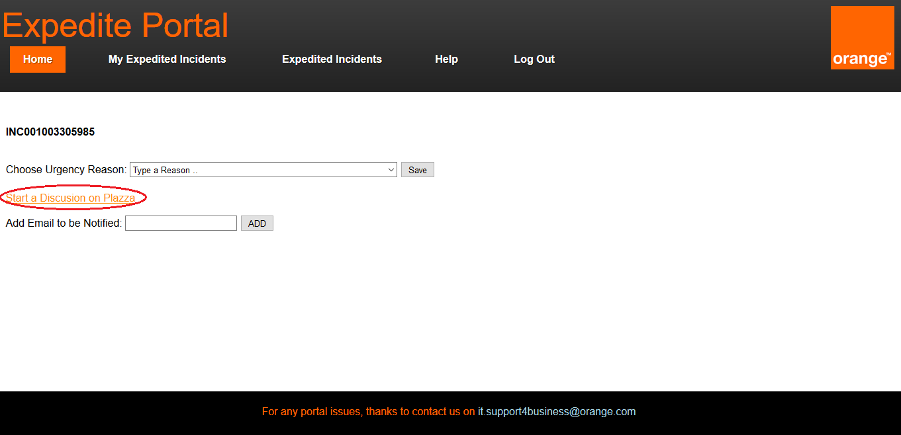

Also the support user can specify emails to be notified about the expediting process by typing the email in the “Add Email to be Notified” and pressing the “ADD” button. A list will be shown consisting of the emails that will be notified about the expediting process. The example below shows what appears when the user types “[example@domain.com](mailto:example@domain.com)” and presses “ADD” button.

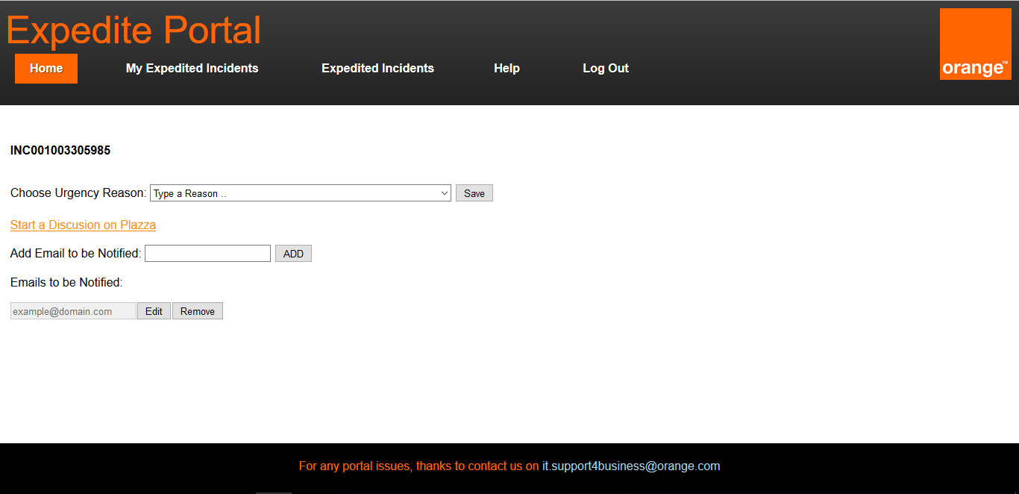

The support user can add more emails by typing the email in the “Add Email to be Notified” and pressing on the “ADD” button. Each email in the list can be edited or removed.

**Expedite Portal – My Expedited Incidents**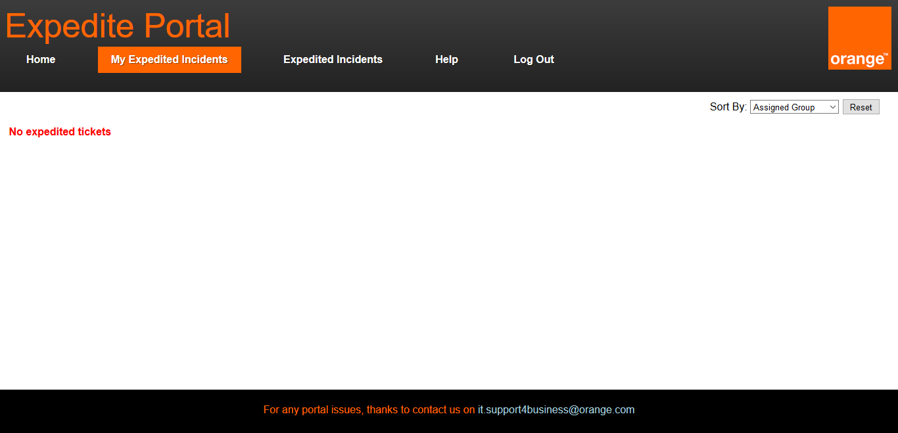

In this page the support user can view all the incidents expedited by them which are not closed. The user can order the table ascendingly with all the columns using the “Sort by” section at the top left corner. Upon selecting the column to sort, the table will instantly be sorted.

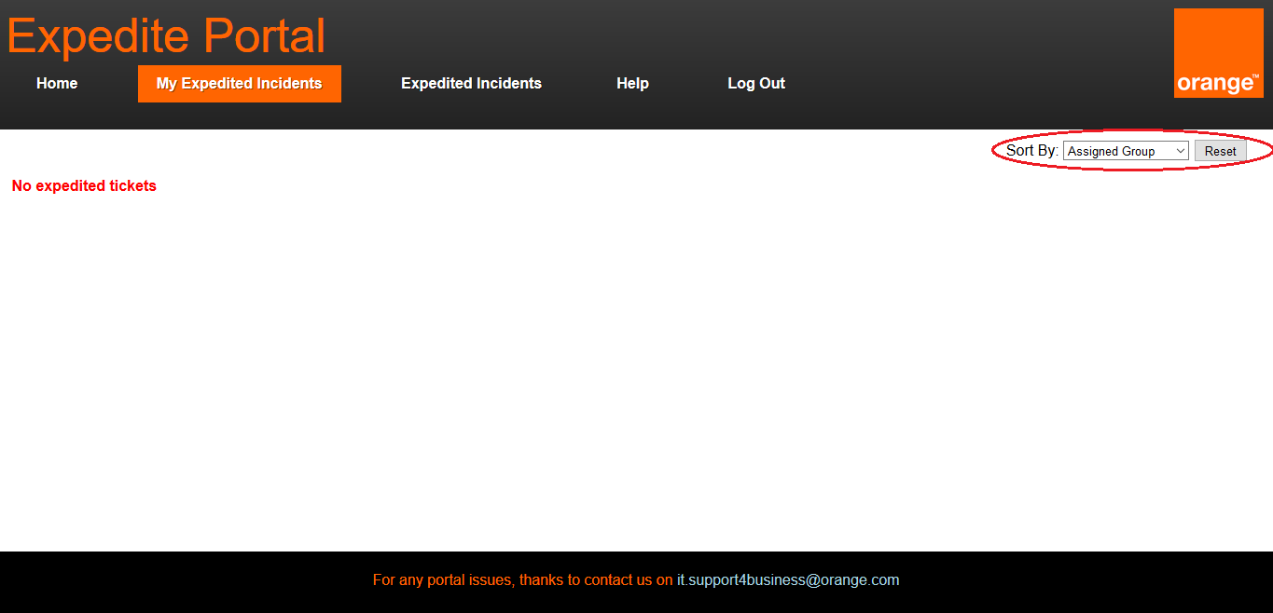

**Expedite Portal – Expedited Incidents**

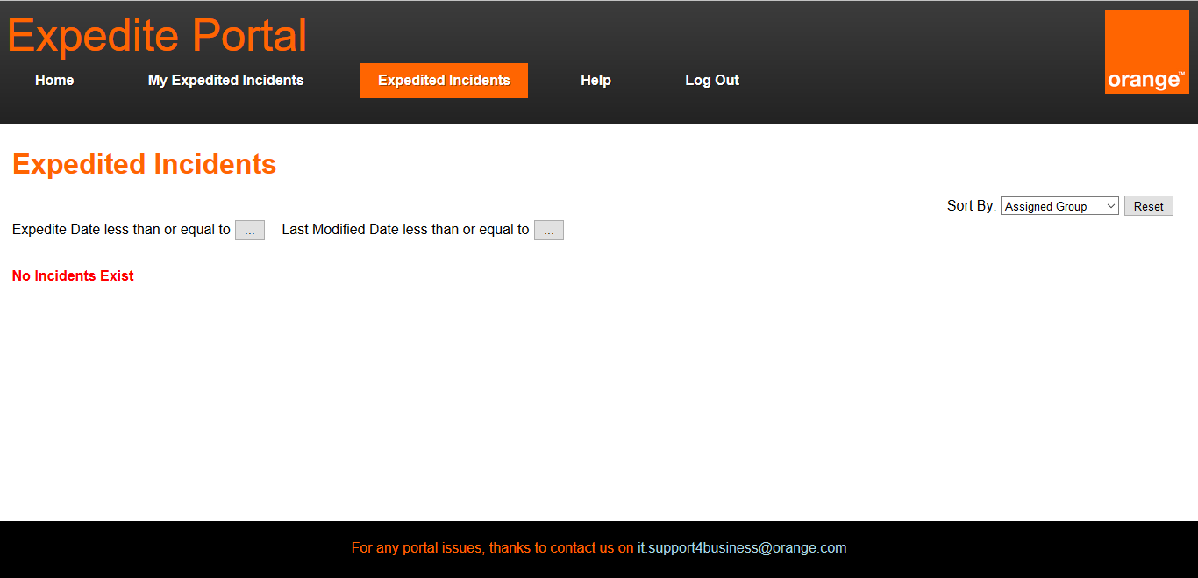

The expedited incidents tab contains all the incidents which are not resolved or closed and are expedited by the group(s) that the support user is assigned to. There are three types of filters in this page: filter (1) or filter (2) can be applied separately while filter (3) is just a sorting filter. The filters are numbered as in the image below.

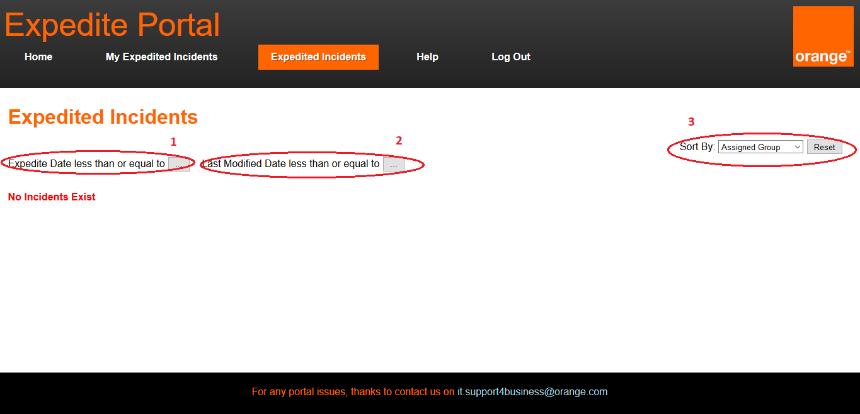

1. This filter is used to show only incidents that are expedited before or equal a certain date by pressing on the “…” button beside the text which states “Expedite Date less than or equal to”. After pressing on the button a calendar will appear for which the user can specify which date they desire.
2. This filter is used to show only incidents that have a last modified date before or equal to a certain date by pressing on the “…” button beside the text which states “Last Modified Date less than or equal to”. After pressing on the button a calendar will appear for which the user can specify which date they desire.
3. The sort filter is responsible for sorting columns ascendingly by choosing the column name to sort upon from the dropdown list.

**Expedite Portal – Other Features**

Throughout the whole portal, any incident in a table view is clickable as shown below.

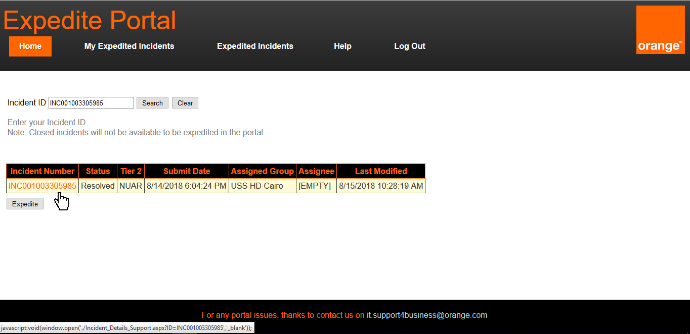

Upon clicking on an incident the following page will open in a new tab containing more information about the incident.

